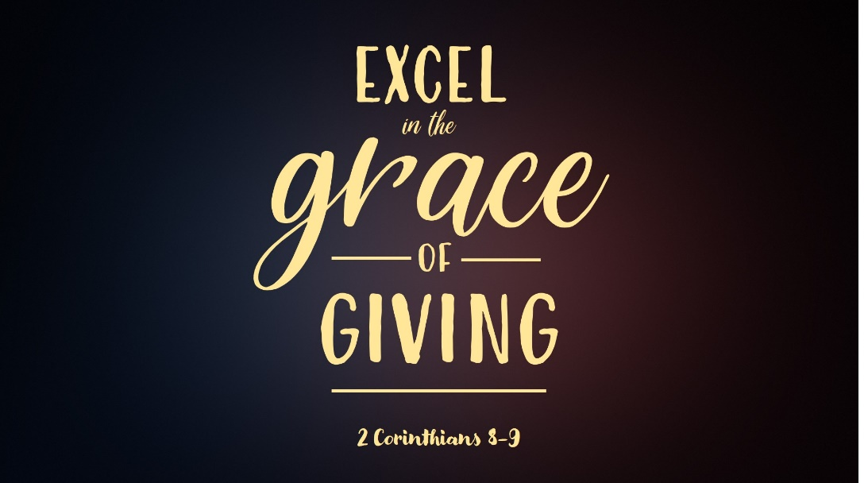

Some people hate tipping at restaurants. I don’t think I have ever given less than 10% and that was for extremely poor service. Generally I just do 20%. I did find a helpful tip online regarding tipping which may come in handy. “If you’re spending $1,000 on a bottle of wine, no one really expects you to add another $200 for the bottle onto the tip.” That’s good to know for the future, don’t you think? We give 10-20% to wait staff at restaurants. We pay 5-10% of our salary to our property tax bill. Our income tax varies widely from 0% to close to 40% of our annual salary. Most of these checks are written rather reluctantly. Then the church comes along and asks us to consider giving something like 10% to the church. There simply is not enough month left at the end of the money to give this much, right?

Everyone in this room is at a different place in their giving habits and their motivation for giving. Some people gladly give a lot and some gladly give a little. Some reluctantly give a lot and some reluctantly give a little. Giving can feel more like paying taxes than worshipping the Lord. Whether you give a little or a lot, I believe that the majority of believers are not content in their giving. We might be complacent, but we are not content—and there’s a huge difference.

I would say that I have become complacent. When I got my first job out of college I had barely ever given money to the Lord’s work. In fact, I can’t recall ever giving. Maybe I did, but if I did it was just pocket change. Somehow I found myself with a giving envelope from The Gideons. I decided to write the biggest check I had ever written to the Gideons in honor of a Gideon from my former church. Once I wrote that check I realized it was not so bad and I also realized that now that I had an income, that this is what I was supposed to be doing. In my little apartment the Lord prompted me to start tithing my income. I didn’t know that we were no longer obligated to tithe but this is all I knew, so I started there. Ever since it has been a relatively easy habit to tithe. It’s just something we do and we’ve managed to go above tithing over the years. But even in that there is a complacency. It’s a habit and I can’t say that we give sacrificially. Probably the only time that has happened was for the capital campaign for this building. Karen and I pledged an amount that wasn’t shockingly large, but given our current giving habits and single income at the time, we did not know how we would do it. It clearly did not fit into the budget. It was a step of faith.

Now we love to give when we can. I think for the most part we are cheerful givers bit what I am saying is that even with solid giving habits, any believer can fall into complacency in this area. That can be true with any aspect of the Christian life and it can certainly be true in our giving. I believe this passage in 2 Corinthians 9 has the ability to break s out of our complacency. I believe there is a principle that is founded in God’s person and character that can radically change our level of generosity.

⁶ The point is this: whoever sows sparingly will also reap sparingly, and whoever sows bountifully will also reap bountifully. ⁷ Each one must give as he has decided in his heart, not reluctantly or under compulsion, for God loves a cheerful giver. ⁸ And God is able to make all grace abound to you, so that having all sufficiency in all things at all times, you may abound in every good work. ⁹ As it is written,
“He has distributed freely, he has given to the poor;
his righteousness endures forever.” (Psalm 112:9)
¹⁰ He who supplies seed to the sower and bread for food will supply and multiply your seed for sowing and increase the harvest of your righteousness. ¹¹ You will be enriched in every way to be generous in every way, which through us will produce thanksgiving to God. ¹² For the ministry of this service is not only supplying the needs of the saints but is also overflowing in many thanksgivings to God. ¹³ By their approval of this service, they will glorify God because of your submission that comes from your confession of the gospel of Christ, and the generosity of your contribution for them and for all others, ¹⁴ while they long for you and pray for you, because of the surpassing grace of God upon you. ¹⁵ Thanks be to God for his inexpressible gift!

Let me remind you of where we have been in this series, to which I will add the tenth principle.

- Grace always precedes giving.
- You can have joy despite a severe trial
- You can have a wealth of generosity despite extreme poverty.
- Give as much as you are able.
- Sacrificial giving is a service to the saints.
- Our giving muscles can be strengthened.
- Generosity cannot be forced.
- Give in proportion to your personal blessing.
- Giving is a direct measure of our love and worship.
- You always reap what you sow.

If I had to choose, I would say that the points #1 and #10 are the key to understanding this passage and the key to our generosity in general. And Paul begins here with sowing and reaping. whoever sows sparingly will also reap sparingly, and whoever sows bountifully will also reap bountifully. When I was a new believer, the church I attended quoted vv. 6-7 each Sunday before the offering plates were passed.

The first and vital thing to understand here is that sowing is giving. The principle of sowing and reaping are found other places in Scripture but here it only referring to financial giving. It’s not a general sowing and reaping of all parts of your life but rather a very specific call to sowing and reaping in your financial generosity. The sowing and reaping analogy is so helpful because the Bible so often uses agricultural illustrations to demonstrate God’s principles. Jesus’ parable of the soils is chief among them. The soil are human hearts and the seed is the transforming gospel. In John 15, all true believers abide in the vine of Jesus and bear much fruit through him. Jesus and other Biblical writers use agricultural analogies so often because the kingdom of God is alive. Non-living illustrations can’t carry the weight of Biblical truth like agricultural and living illustrations. This passage is no exception.

So if sowing is the sharing of our finances, what so we reap in return? You might be inclined to say that what we reap is non-material things. In other words, if we sow generously, we reap joy and contentment. If we sow generously, we reap all manner of God’s blessings in our life. There’s no question that sowing your money will reap all kinds of blessings form the Lord. We’ve already talked about some of those in this message series, but in this passage, what you reap is more money. You heard me right. If you sow money you will reap more money in return.

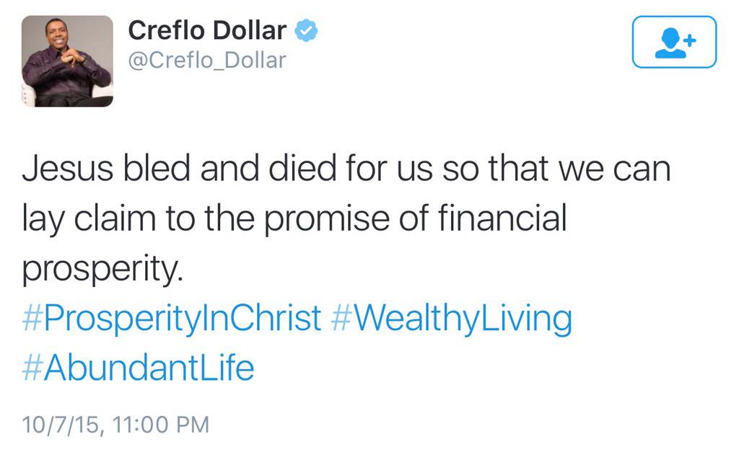
Now some of you don’t know me very well and you might be inclined to stand up and walk out because it sounds like I just gave a clear approval to prosperity theology. Before I explain what I mean, let me be clear about what I don’t mean. Just to be clear—I loathe the prosperity gospel. The prosperity Gospel can be summed up in a single tweet from Creflo Dollar. “Jesus bled and died for us so that we can lay claim to the promise of financial prosperity.” This is heinous blasphemy and should be condemned in the strongest possible terms.

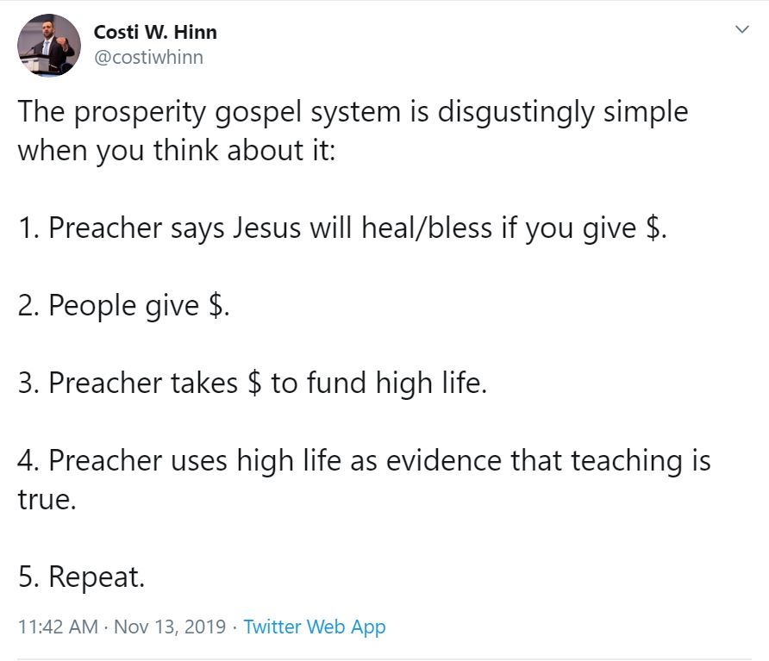
If this teaching is so awful, why do so many follow after it? Costi Hinn is the nephew of Benny Hinn, one of the most well-known prosperity and word of faith teachers. Costi used to run in these circles with his uncle and stay in hotel rooms that cost thousands of dollars per night but has since soundly rejected all of it. He has a simple explanation of why it works. Or put another way, people are desperate and consistently cling to false hope.

Just how much money do these false teachers bring in? In this short video clip Kenneth Copeland will gladly tell us. There it is--$1.3 billion dollars. And this is just one prosperity preacher among countless others.

So we soundly condemn prosperity gospel in the strongest terms. If that is the case, what then did I mean when I said that if you sow money you will reap more money in return? For the answer look at verse 10. He who supplies seed to the sower and bread for food will supply and multiply your seed for sowing and increase the harvest of your righteousness. OK, let’s break this down. Seed always means money in this passage. Paul is saying that God supplies seed to the sower. Do you agree with that? Is God the one who supplies all of your seed—all that you have? I think we all strongly agree with this truth. But the next part is a vital truth most believers don’t understand. Here’s what God does: He will supply and multiply your seed for sowing and increase the harvest of your righteousness.

Are you following the steps here? The passage started in verse six with sowing and reaping. whoever sows sparingly will also reap sparingly, and whoever sows bountifully will also reap bountifully. Now we learn in verse ten that as we sow the seed of our financial generosity, what re reap in return is more seed. The text says that God will supply and multiply your seed for sowing. So as we sow our financial seed what happens is that God supplies and multiplies our seed for even more sowing. So when we give money to the Lord’s work, what we reap is even more money to be given away.

One of the hindrances to grasping this truth is the fact that prosperity teachers uses this same passage and similar idea to propagate their message. They are constantly talking about seed gifts. If you give a $100 seed gift, God will reward you financially. If you sow a $1000 seed, God will multiply that many times over until you become rich. Sowing seeds is an extremely manipulative way for these people to convince you to part with your hard-earned money and send it to them. Even worse is the extremely sad story of little Olive Heiligenthal. Olive is the daughter of Bethel Worship leaders who suddenly and tragically died eight days ago. Ever since they have been holding prayer vigils to pray for her resurrection. They are tens of thousands of people who are absolutely convinced that God will raise Olive from the grave. Someone in the church started a GoFundMe campaign for the family and one contributor made the comment that he gave a donation “seeding into the resurrection.” All of these examples are serious distortions of the beautiful truth of sowing a seed.

This passage is one of the main principles in Randy Alcorn’s book, The Treasure Principle. “God prospers me not to raise my standard of living, but to raise my standard of giving.” Alcorn is saying what I am saying. The more money you sow into God’s work the more he will give you so you can give even more.

This is the same truth found in Proverbs 11:24-25. “There is one who scatters yet increases all the more. There is one who withholds, and it results only in want. The generous man will be prosperous.”

So that you don’t think I am creating a principle that isn’t actually in the text, every commentary I could find agrees with this conclusion.

“God continues to enrich the benevolent person so that he can go on enriching others by his generosity. The greater the giving, the greater the enrichment. The greater the enrichment, the greater the resources to give.”

“So there God is the Giver on the back side of our giving again: he gives the seed so we can scatter it abroad.”

“God enriches us so that we may give even more bountifully.”

“The more one gives to others, the more he is enriched, and thus he can be generous on every occasion.”

“He who provides seed for the sower and bread for food,” which proves that God will continue to supply them so they can continue to give.”

- God supplies and multiplies the Corinthians store of seed intended for sowing.
- The Corinthians sow this seed by giving generously.
- A rich harvest results from their righteousness.
- God swells that harvest enlarging its proportions.

So here’s the enormous difference between prosperity theology and what I am calling grace giving.

Prosperity Theology—Give in order to get

Grace Giving—Give in order to get in order to give

I call it Grace Giving for several reasons. First, we have seen throughout chapters 8 and 9 of second Corinthians that all giving is nothing but a response to God’s grace. Grace always precedes giving. Because God has given is the miracle of unmerited salvation and everything else in our lives, grace giving is the natural result.

2. The second reason it is grace giving is because giving is always freely given. ⁷ Each one must give as he has decided in his heart, not reluctantly or under compulsion, for God loves a cheerful giver. Anything that is not forced or is from grace. This agrees with principles #7 and #8.
- Generosity cannot be forced.
- Give in proportion to your personal blessing.

God asks us to be cheerful givers, but we need to remind ourselves that God is the ultimate cheerful giver. Hebrews 12 instructs us that we are to look to “Jesus, the founder and perfecter of our faith, who for the joy that was set before him endured the cross, despising the shame, and is seated at the right hand of the throne of God.” We just finished celebrating Christmas and Jesus’ first coming, but all

3. The third reason this is called grace giving is because Christians are no longer bound to the tithe. This is debated among Christians but in my opinion, it is clear that the command to tithe no longer applies to us. This passage is a great example. If there was anywhere in the NT where Paul could have taught on tithing it would have been here. Paul spent all of chapter eight and chapter nine writing about the collection for the poor saints in Jerusalem. This is by far the longest section in the New Testament on giving and if the Old testament tithe still applied, Paul would have surely told us so.

Some Christians get a little nervous when you say the tithe no longer applies because they worry that will take away motivation for giving. But that’s where grace makes up the difference? Tithing was part of the Law and Grace Giving is under grace. Which has more power, law or grace? Furthermore, I think that tithing can bring about complacency. If you are able to give 10% of your income it’s easy to stop there. But grace giving can go way beyond 10%.

I’d like to bring this toward application with a quote from John Piper.

In God's mathematics the best way to increase a sum is to subtract from it. Verse 6: "He who sows sparingly will also reap sparingly, and he who sows bountifully will also reap bountifully." Most people operate on exactly the opposite principle to this one, namely, We will have more if we give less. But the Bible says, You will have more if you give more. This doesn't sound like good mathematics. Ten minus one is nine. And ten minus zero is ten. So if you want to have ten instead of nine, you subtract zero from the checkbook on the first day of the week. Right? Wrong! The problem with that math is that it leaves God out. That's what I am trying to change this morning--to put God and his promises back into your finances. God says: if you subtract more seed from your bag you have more than if you subtract less seed from your bag. That's God's promise to you. Put him to the test.

Piper is simply making application of the sowing and reaping principle. So here’s where I want to pull all four messages together. Do you believe that if you give, God will supply your seed for more giving? Here’s my challenge for you.
- Determine the % of income your currently give. I don’t mean just your giving to Grace Church. Remember, this about your walk with Jesus, not our church budget. All of your charitable giving, church, missions, etc.
- Whatever that amount is, what do you think is holding back your giving? Are you a cheerful giver? Do you give out of God’s grace or is it more from obligation?
- Whatever that amount is, could you increase that by 1% or 2% in the next year? If you gave 1% more do you believe that God will supply that 1%? Do you believe verse 8, that God is able to make all grace abound to you, so that having all sufficiency in all things at all times, you may abound in every good work.

Rich Maurer
December 29, 2019

https://www.eater.com/2018/11/28/18112819/tipping-in-america-guide-restaurants-how-much
Randy Alcorn, The Treasure Principle.
Harris, Murray J., 1976, the Expositors Bible Commentary, Zondervan Publishing, Grand Rapids.
Piper, John, March 20, 1998, He Who Sows Bountifully Will Reap Bountifully.
Wiersbe, W. W. 1996, c1989. The Bible exposition commentary. "An exposition of the New Testament comprising the entire 'BE' series"--Jkt. Victor Books: Wheaton, Ill.
Walvoord, J. F., Zuck, R. B., & Dallas Theological Seminary. 1983-c1985. The Bible knowledge commentary : An exposition of the scriptures. Victor Books: Wheaton, IL
Keener, C. S., & InterVarsity Press. 1993. The IVP Bible background commentary : New Testament . InterVarsity Press: Downers Grove, Ill.
Murray Harris, NIGTC, The Second Epistle to the Corinthians, Eerdmans Publishing, 2005, p. 644.
“The prosperity gospel says you should give in order to get—and stops there. The Bible says you should give in order to get—so you can give even more away.” (Sam Storms) https://www.thegospelcoalition.org/article/paul-teach-prosperity-gospel/
Piper, John, January 19, 1992, Enough For Us: Abundance For Every Good Work.

