Colossians 1:24-29

²⁴ Now I rejoice in my sufferings for your sake, and in my flesh I am filling up what is lacking in Christ's afflictions for the sake of his body, that is, the church, ²⁵ of which I became a minister according to the stewardship from God that was given to me for you, to make the word of God fully known, ²⁶ the mystery hidden for ages and generations but now revealed to his saints. ²⁷ To them God chose to make known how great among the Gentiles are the riches of the glory of this mystery, which is Christ in you, the hope of glory. ²⁸ Him we proclaim, warning everyone and teaching everyone with all wisdom, that we may present everyone mature in Christ. ²⁹ For this I toil, struggling with all his energy that he powerfully works within me.

Is there anything wrong with bribing your children into doing what you want them to do? Don’t think too hard about it. Just give me a quick yes or no. It’s not quite that simple, is it? In one sense, all parenting is somewhat a form of bribing, but you want to stop short of obvious, blatant manipulation of your children. But occasionally I crossed that line. When Ryan was young, he really wanted to watch The Lord of the Rings movies. In that desire, I saw a golden opportunity for unapologetic bribery. I told Ryan that I would let him watch the movies if he could exhibit more maturity in the next 6-12 months. The challenge was to explain what I meant by maturity and how we would know if he was growing in maturity. Back then we had regular talks about his progress but one ongoing thread through those months found Ryan struggling with this idea of maturity. I tried to be as clear as possible—after all, I wanted the “bribe” to work, right—but often the idea of maturity was a little too abstract for his young mind.

The same can be true for most believers. What is Christian maturity? What does it look like and most importantly, how we do get there? This is exactly what Paul was aiming at in this passage, which us summarized in verse 28—that we may present everyone mature in Christ. I would say that this is not only the theme of this passage, but it is also the theme of the entire Bible and the Christian life.

This message that will continue next Sunday has four parts.

- The Purpose
- The Pillar
- The Process
- The Power

What I am talking about this morning is point #1—the purpose. Again, that is summarized by verse 28—that we may present everyone mature in Christ. This is the end goal, the ultimate purpose of why you even exist. Why were you given breath of life? So that you may become mature in Christ. This one phrase answers every philosophical, sociological and relational question you could ever ask. What is the purpose of life? The purpose of life is that we may present everyone mature in Christ. I know the Westminster Confession says it a little differently.

Some of you will recognize the logo I have on the powerpoint slide. Telios is a year long program at Living Waters which has the goal of growing in Christian maturity. In fact, the word telios is the Greek word for maturity. The word mature in verse 28 is the word telios. Here is the definition of the word.

- brought to its end, finished
- wanting nothing necessary to completeness
- perfect

Notice that the word ‘mature’ does not appear in the definition. I’ll explain that in a moment. This verse is central to a well-known verse. You therefore must be perfect, as your heavenly Father is perfect (Matthew 5:48). That verse can trouble you a little because the standard seems so high. I would much rather be told that I am supposed to be mature than to be told that the standard is perfection.

Telios occurs in an even more well-known verse. So when Jesus had received the sour wine, He said, “It is finished!” And bowing His head, He gave up His spirit (John 19:30). Jesus literally said tetelestai, which is a form of the word telios. His work of salvation was finished. It was complete. Nothing was left to make it more complete, more finished. Are you starting to get the idea of what maturity actually means?

However, in everyday life we define a mature person as one who is responsible and basically a nice person. We essentially divide people into two broad categories—those who are mature and those who are not. Maybe we will expand it a bit and say, “she is a very mature person,” meaning that we recognize that she is more mature than the average person. But we never define maturity as perfection or completion, do we? Now understand that neither Paul nor Jesus is referring to sinless perfection. Both recognize a lifetime struggle with sin. So we are not talking about that kind of perfection, but that doesn’t change the fact that the word telios/maturity means complete or finished.

Can you feel the tension here? True Biblically informed spiritual maturity is way beyond what we usually make it to be. So we have get rid of this substandard definition of maturity that sets the bar extremely low. With this kind of definition, most of us could hit that mark. It won’t do anyone any good to lower that standard of maturity to make it easier to achieve. That is just self-deception and thinking more highly of yourself than you ought. But on the other end of the spectrum is sinless perfection, and we have rejected that as the goal. So if the goal is not mediocre maturity on the one end or sinless perfection on the other end, what exactly is maturity that is complete and perfect?

I’d like to suggest that we go back to the Master Disciplemaker and see how he defines maturity, then we will have the best of Jesus’ and Paul’s teaching on the subject. First I want you to see how often Jesus used agricultural parables and illustrations.

- The Vine and the Branches
- A Tree and its Fruit
- Wheat and the Weeds
- The Sower and the 4 Soils
- The Mustard Seed/Tree
- Unfruitful Fig Tree
- The Growing Seed
- Workers in the Vineyard
- Fishers of Men
- Keeping the Good Fish
- The Lost Sheep
- The Sheep and the Goats
- Rich Man Builds Bigger Barns

That’s quite a list, isn’t it? So here’s the next question. Why did Jesus use so many agricultural parables? People tend to believe that Jesus used agricultural parables because he lived in an agricultural society. That’s what they knew. Every day of their lives the vast majority of them were involved in some kind of farming and fishing, including his own twelve disciples. Jesus was the master teacher so it makes sense that he made use of these real life experiences to teach deeper truth.

That explanation feels about right, doesn’t it? and it’s not wrong. It’s all true, it’s just not the most complete answer. Here’s another question. If Jesus had loved today, would he use illustrations from the business world, technology and social media? Would he use examples of Hollywood movies and computers? He certainly could and I can’t say that he absolutely would not have used these things in his parables, but I can confidently say this much. The vast majority of his parables would still have been based in agriculture? How do I know that? His parables are describing the kingdom of God and the kingdom of God cannot ever be reduced to an inanimate object like a computer or cell phone. The kingdom of God us alive. It is living and growing. Everything about the kingdom of God requires that it be described and taught in terms of living things.

Let’s take this one step further. Did Jesus pattern his parables of the kingdom of God on the agricultural world? In other words, did he understand that the kingdom is living and growing and wheat and fig trees and living and growing, therefore these would make ideal illustrations of the kingdom? Or did he pattern agriculture on the Kingdom of God? Do you see the fundamental question I am asking here? What I am saying is that Jesus invented agriculture—a living entity—as an illustration of the kingdom of God. Do you see the profound significance of this? It’s one thing to say that Jesus used agriculture to illustrate the kingdom of God but it’s much more wonderful to see that he patterned agriculture in order to illustrate the kingdom of God.

Let me give you an illustration we covered when I preached through Ephesians. We should all be familiar with this section of chapter five.

²² Wives, submit to your own husbands, as to the Lord. ²³ For the husband is the head of the wife even as Christ is the head of the church, his body, and is himself its Savior. ²⁴ Now as the church submits to Christ, so also wives should submit in everything to their husbands.
²⁵ Husbands, love your wives, as Christ loved the church and gave himself up for her, ²⁶ that he might sanctify her, having cleansed her by the washing of water with the word, ²⁷ so that he might present the church to himself in splendor, without spot or wrinkle or any such thing, that she might be holy and without blemish. (Ephesians 5:22-27)

This beautiful and difficult to obey passage says that the love a husband has for his wife should be like the love that Christ demonstrated for the church. And the wife’s submission to her husband should be the same as the church submitting to Christ. So tell me this. Did Paul use the gospel to illustrate marriage or did God invent marriage to illustrate the gospel? We don’t have to argue this point because Paul gave us the answer at the end of the chapter. ³² This mystery is profound, and I am saying that it refers to Christ and the church. The mystery is Christ and the church. In other words, marriage is to be modeled after the gospel because God created marriage as a living, breathing illustration of the gospel. He did not use the gospel as a convenient illustration of marriage, rather he created marriage to powerfully illustrate the gospel.

We can see this all throughout Scripture. Take Proverbs 6 as an example.

Go to the ant, O sluggard;
consider her ways, and be wise.
7 Without having any chief,
officer, or ruler,
8 she prepares her bread in summer
and gathers her food in harvest.
9 How long will you lie there, O sluggard?
When will you arise from your sleep?
10 A little sleep, a little slumber,
a little folding of the hands to rest,
11 and poverty will come upon you like a robber,
and want like an armed man.

As before, there are two ways to view this. We can learn a life lesson from the ants, but much better even is to understand that God created the ants to function this way to teach us all kinds of lessons.

If we understand that God created living things with the express purpose of illustrating him and his gospel, this allows us to have a fresh perspective on a passage like John 15. “I am the true vine, and my Father is the vinedresser. Every branch in me that does not bear fruit he takes away, and every branch that does bear fruit he prunes, that it may bear more fruit (John 15:1-2)

Jesus is not a literal vine, but he did create the vine to illustrate how we are connected to him as a single living entity. And here is where we see what maturity looks like—bearing fruit. If you are bearing fruit you are becoming more mature. In a little bit I will show you what that fruit looks like but for now, make sure you understand that fruitfulness is the measure of what it means to be mature. Here are a few other verses that equate maturity with fruitfulness.
.
- Whoever abides in me and I in him, he it is that bears much fruit, for apart from me you can do nothing (John 15:5).
- Other seeds fell on good soil and produced grain, some a hundredfold, some sixty, some thirty (Matt 13:8).
- You will recognize them by their fruits (Matt 7:16).

Do you see what I mean? Spiritual fruit is the measure of Christian growth and maturity. So God created agriculture and all growing things so that we could understand this principle. But that leads us to ask two more questions. If fruitfulness is that standard of spiritual maturity, what does fruit look like? What am I supposed to produce and the second question is how much is enough? How will I know when I have reached telios, the point of completion or maximum fruitfulness?

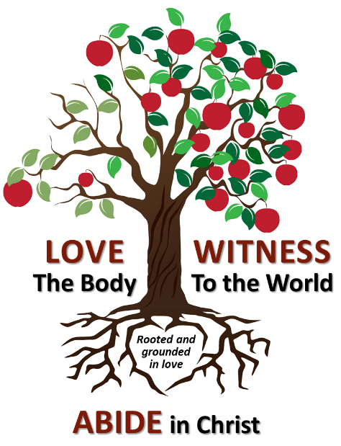
For the past few years we have been using an oak tree to represent our disciplemaking at Grace, that we have called Oaks of Righteousness. Oaks of righteousness is found in Isaiah 61, so it is a Biblical term and it represents growth and strength.

However, an oak tree cannot convey the idea of fruitfulness, therefore we are changing the model from an oak tree to a fruit tree. Also, we have changed a few terms. We have kept abiding in Christ because that is inseparable from the idea of a living organism that produces fruit but more importantly, it’s inseparable from Jesus as the vine in John 15. We are changing shepherd the body to love the body. We thought shepherding might seem like something only elders and pastors do, not all believers. And we changed rescue the perishing to witness to the world. Rescue is not our job, that’s God’s work. Our job is to witness, to proclaim the truth.

Now back to identifying the spiritual fruit. Jesus made it simple for us. He said that we are to go and “make disciples of all nations, baptizing them in the name of the Father and of the Son and of the Holy Spirit, teaching them to observe all that I have commanded you.” I said it was simple, but I didn’t say it was easy. The spiritual fruit in our lives is supposed to be all that Jesus has commanded us. That’s what maturity looks like. That’s what telios, perfection and completion looks like. Now that sounds overwhelming which is why we have broken it down into only three parts, abide in Christ, love the body and witness to the world. Or if you prefer, you could simplify it the same way Jesus did. “You shall love the Lord your God with all your heart and with all your soul and with all your mind…and…You shall love your neighbor as yourself.” (Matthew 22) Abiding in Christ is loving God and taken together, loving the body and witnessing to the world is loving your neighbor. There is nothing easy about doing this, but it is remarkably simple.

If you bear this sort of fruit, that’s what it means to be a disciple. But there is a bit more to bearing fruit which can be illustrated with a simple question. what is the fruit of an apple tree? Obviously, the fruit of an apple tree is an apple. but the ultimate fruit of an apple tree is another apple tree. We are not asked to merely be a disciple or grow as a disciple, but we are asked to make more disciples. Jesus said go to the nations and make disciples. Paul was clear about this in a verse I used last Sunday, 2 Timothy 2:2.

what you have heard from me in the presence of many witnesses entrust to faithful men, who will be able to teach others also.

Remember, there are four levels of discipleship in this one verse. First, Paul helped Timothy to become a disciple. What did that make Paul? He was no longer just a disciple, but Paul became a disciplemaker. Then as Timothy grew and matured, he was able to raise up faithful men. That’s plural—men, more than one. So Timothy helped to grow several men into disciples. Then at some point they were equipped to do the same thing for others.

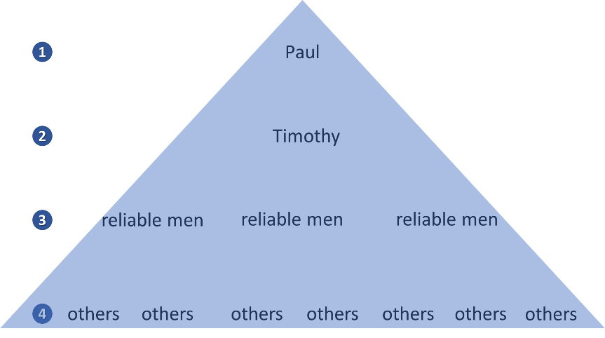
The same idea can be pictured like this. At each level the next person becomes a disciple and a disciplemaker. As it continues and grows, you don’t just get a few more disciples, you get a multiplication of disciples and disciplemakers. With God’s grace, you get an unstoppable force of disciples and disciplemakers.

There is one last question to understand maturity—how much fruit do I need? If spiritual fruit determines my spiritual maturity, my completeness, my telios, how much fruit do I need to be mature? This question is simultaneously overwhelming and very encouraging. How much fruit? Believers are alive and the Holy Spirit within you is alive and so you will never have all of the spiritual fruit you could have.

You’ve heard the old question, how do you eat an elephant? One bite at a time. As long as you have breath of life, you have the opportunity to feast on the wonder of God’s kingdom. It’s an infinite kingdom with infinite potential, so you have the opportunity to never stop growing. You will be complete when your eyes close in death, but that’s just the first step into eternity. So in this sense, you will never have enough fruit, but do you see that is a good thing? And on the other side of the spectrum, it’s never too late to start. It doesn’t matter if you have wasted opportunities up until this point, all that matters is whether or not you want to begin the process.

Rich Maurer
June 23, 2019

