Next month dozens of quizzers, coaches, table officials and family members from our area are headed to Green Lake Conference Center for the national Bible quiz tournament. Our local Bible quiz ministry is hosting the tournament and the theme we chose this year is from John 18—Not of this World. This fits perfectly with our preaching schedule. We took a break from the gospel of John to look at Thessalonians. At that time I told you I would get back to John and finish up the book around the time of Easter because that is where we left off in the text. So here we are and the timing with nationals worked our perfectly.

John 18 is a long chapter so I won’t be reading all of it, but it has to do with Jesus arrest and appearance before Annas, Caiaphas and Pilate. The events of this chapter are what the scribes and Pharisees have wanted for years. They devised and schemed behind the scenes. They tried to arrest him. They tried to throw him off a cliff. They made master plans to take Jesus out, but they all failed—until this night.

Judas betrayed him. Peter denied him. Soldiers arrested him. Religious leaders mocked him. And the Romans crucified him. They were not able to do any of these things for over three years and then suddenly they all happened within a 24 hour period. Based on the way this all played out, we need to answer two key questions. How did it happen that way? And Why did it happen this way.

The how question is pretty simple. Jesus had perfect knowledge and absolute control over all circumstances. He knew what everyone was going to do and when they were going to commit these evil acts against him. But he not only knew all of this, he controlled all of this. Absolutely nothing happened without his permission. He had absolute control over everything and everyone. His full deity was on display. This is his identity.

The why question comes from verse 36, which is also the theme of Nationals. Jesus told Caiaphas that “My kingdom is not of this world.” In other words, Jesus had an infinitely greater purpose in mind. His purpose was to enter this world—the world he created—and set forth a plan of redemption. He entered this world to bring his people to another world. He was on a divine rescue mission and the cross was the path to redemption. This was his purpose.

Everyone in this story who opposes Jesus fails to grasp either his identity or his purpose—or both. Most certainly failed to grasp his true identity and even his disciples failed to grasp his purpose. And the same holds true for us. All of our struggles in this life can largely be divided into these two categories. Either we fail to grasp his identity or his purpose—or both. Let’s walk our way through the story and see why we need to embrace Jesus’ identity and purpose. The chapter begins with Judas’ betrayal.

We see from verse two that Judas had set the perfect trap for Jesus. “Now Judas, who betrayed him, also knew the place, for Jesus often met there with his disciples.” The arrest and trial of Jesus had to be done in secret to avoid the crowds. The arrest was done in secret and the trial before Annas and Caiaphas was done in secret. This is also why it was all done at night. It was illegal to hold a religious trial at night and in secret. This would have to be done by someone who knew the most about Jesus’ ministry patterns and places. Humanly speaking, only a close disciple could have pulled this off. In many ways it looked like the perfect set up. If this were merely a human story with no divine players, it would have been the perfect set up.

But Jesus had perfect knowledge of everything. Verse four reads, “Then Jesus, knowing all that would happen to him, came forward and said to them, “Whom do you seek?” Ponder that phrase for a moment—knowing all that would happen to him. It’s no wonder he sweat blood in the garden. And of course earlier that night he had already predicted that Judas would be the betrayer. “Truly, truly, I say to you, one of you will betray me.” (John 13:21) and of course he had long predicted his arrest. “From that time Jesus began to show his disciples that he must go to Jerusalem and suffer many things from the elders and chief priests and scribes, and be killed, and on the third day be raised” (Matthew 16:21).

But it gets better still. When Jesus asked who they were seeking, They answered him, “Jesus of Nazareth.” Jesus said to them, “I am he,” they drew back and fell to the ground. This is a clear statement of Jesus’ deity. Most believers know that the “I am” statement is the name God gave to Moses at the burning bush. It is the quintessential divine name. Jesus used many ‘I am’ statements as well but we forget that it was used all throughout the Old Testament. Just in Isaiah chapters 40-55 “I am” is used almost 50 times. Here are a few examples.

Isaiah 43:11—I, I am the Lord, and besides me there is no savior.

Isaiah 43:25—“I, even I, am he who blots out
your transgressions, for my own sake,
and remembers your sins no more.

These verses are clear statements of deity and sovereignty over salvation. The ‘I am’ is the only savior. The ‘I am’ is the one who blots out transgressions. These and many other Old Testament passages would have informed those who were arresting Jesus. All he did was answer “I am” and they all fell backwards. Why they still arrested Jesus after this we don’t know but what we can say for sure is that it was purposed to be. They caught a glimpse of Jesus’ identity, but it was not enough to change their behavior.

Isaiah is also a great passage to demonstrate that knowledge of future events is evidence of deity.

“Tell us, you idols,
what is going to happen.
Tell us what the former things were,
so that we may consider them
and know their final outcome.
Or declare to us the things to come,
tell us what the future holds,
so we may know that you are gods.
Do something, whether good or bad,
so that we will be dismayed and filled with fear. (Isaiah 41:22-23)

The unmistakable truth here is that false gods do not know the future. The Lord is taunting the false idols to describe what has taken place or declare the things to come. This is a foundational way to tell the difference between a false god and the true God. Only the true God can tell the future. Only the true God has perfect knowledge of future events. “Then Jesus, knowing all that would happen to him…” Jesus had perfect knowledge of future events which help solidify his divine status. This was no ordinary man.

The same was true with Peter’s denial. Jesus predicted it with precision.
³³ Peter answered him, “Though they all fall away because of you, I will never fall away.” ³⁴ Jesus said to him, “Truly, I tell you, this very night, before the rooster crows, you will deny me three times.” ³⁵ Peter said to him, “Even if I must die with you, I will not deny you!” And all the disciples said the same (Matthew 26:33-35).

Events played out exactly as Jesus had predicted.

¹⁷ The servant girl at the door said to Peter, “You also are not one of this man's disciples, are you?” He said, “I am not.”

²⁶ So they said to him, “You also are not one of his disciples, are you?” He denied it and said, “I am not.”

²⁶ One of the servants of the high priest, a relative of the man whose ear Peter had cut off, asked, “Did I not see you in the garden with him?” ²⁷ Peter again denied it, and at once a rooster crowed.

It’s right here that Matthew adds something that John did not include.
And Peter remembered the saying of Jesus, “Before the rooster crows, you will deny me three times.” And he went out and wept bitterly (Matthew 26:75).

Matthew also added Judas’ response.
3Then when Judas, his betrayer, saw that Jesus was condemned, he changed his mind and brought back the thirty pieces of silver to the chief priests and the elders, 4saying, “I have sinned by betraying innocent blood.” They said, “What is that to us? See to it yourself.” 5And throwing down the pieces of silver into the temple, he departed, and he went and hanged himself (Matthew 27:3-5).

What a difference between these two men. When we get to chapter 21 we will see Peter’s full restoration by Jesus himself. One wept bitterly and the other took his life. Why? We may never know for sure but given the fact that Judas was already stealing money from Jesus long before he betrayed him would cause us to think that he was not saved at all. He repented. In fact, both Peter and Judas knew they had sinned. Both had great sorrow for their sin. The difference is that Judas never sought forgiveness from Jesus. He had every opportunity to do so. Jesus would have received him as he received Peter but instead of turning to Christ, Judas turned further away from Christ.

A major question arises when we look at how these events played out. Jesus predicted that Judas would betray him and that Peter would deny him three times. If Jesus had perfect knowledge about these events that means that Judas could not have decided to not betray Jesus and Peter could was going to deny Jesus no matter what. This is why God’s omniscience cannot be separated from his omnipotence. If he knows all things then he controls all things.

This is seen quite explicitly in the early chapters of Acts. Notice that what is being described here are the very events of John 19.

this Jesus, delivered up according to the definite plan and foreknowledge of God. (Acts 2:23)

for truly in this city there were gathered together against your holy servant Jesus, whom you anointed, both Herod and Pontius Pilate, along with the Gentiles and the peoples of Israel, to do whatever your hand and your plan had predestined to take place (Acts 4:27-28).

Now we have to be careful here because both Judas and Peter actually made these sinful decisions. They are responsible for their own decisions. In one sense, they freely made those decisions but in another sense, God was in control of them as well. There is a certain mystery when you ask these questions but one thing it disproves is libertarian free will.

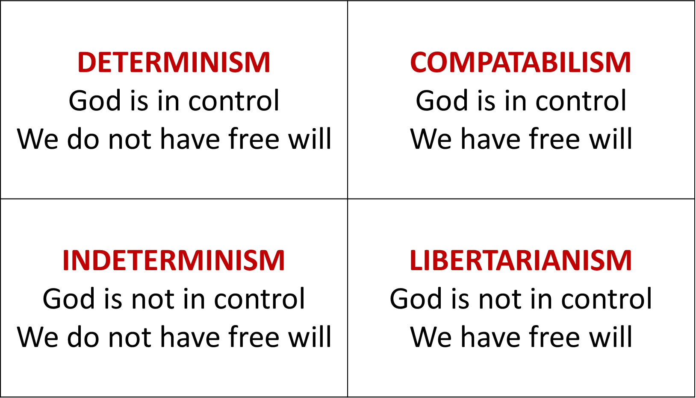
Libertarian free will—not to be confused with the political position of Libertarianism—is the belief that we have free will and because of that fact, God is not in control. This view would say that Judas and Peter could have decided not to have betrayed or denied Jesus. In other words, they could have done something other than what Jesus predicted they would do. Out of these four options, determinism and indeterminism are Biblically impossible positions so the only viable option that remains is compatablism. God is in absolute control of all things but within that sovereign control, we are responsible for our own decisions. The Bible clearly affirms both of these as true.

But the problem is that most Christian tend to operate in the realm of libertarian free will. While most would not say that God is not in control—because he can’t predict the future if he is not in control—at the end of the day, many believers elevate free will far too highly. We like to be in charge of our own destiny. We like to think that our decisions are ours alone, but in so doing, we lose God’s sovereign hand over our lives. To Rob God of any of his power is to rob him of his divine nature. We might say that we believe that Jesus is fully God but if we think we are in charge of our own faith and our lives, to us, he is less God. We change his very essence, his identity and in the end, we, not Jesus, lose out.

We can fail to grasp his identity but we can also fail to grasp his purpose. While Jesus was on trial for his very life and Pilate asked him if he was the kind of the Jews, he explained his purpose.

³⁶ Jesus answered, “My kingdom is not of this world. If my kingdom were of this world, my servants would have been fighting, that I might not be delivered over to the Jews. But my kingdom is not from this world.”

What does it mean that Jesus is not of this world?

- His kingdom existed before the world.
John told us this at the beginning of his gospel.
The true light, which gives light to everyone, was coming into the world. He was in the world, and the world was made through him, yet the world did not know him. He came to his own, and his own people did not receive him (John 1:9-11).

As Creator of the world, Jesus was outside of the world. He had to humble himself to take on human flesh and human limitations. He entered this world to redeem his people, but he was mostly received with rejection and unbelief.

- He did not take up literal swords because his battle was spiritual.
There is spiritual warfare going om all of the time. The Bible records some of this for us. We see this in the book of Daniel when the archangel Michael was prevented from coming to Daniel by the “prince of Persia.” So the battle is real and it rages all of the time in the invisible, spiritual realm.

However, when it came to the most significant event in human history, Jesus did not fight. After Peter sliced off a man’s ear, Jesus said to Peter, “Put your sword into its sheath; shall I not drink the cup that the Father has given me?

Matthew records a longer conversation at that moment.
Then Jesus said to him, “Put your sword back into its place. For all who take the sword will perish by the sword. Do you think that I cannot appeal to my Father, and he will at once send me more than twelve legions of angels? But how then should the Scriptures be fulfilled, that it must be so?” (Matt 26:52-54)

There’s only one reason why Jesus would not fight. His kingdom was not of this world. Luke 19:10 says, For the Son of Man came to seek and to save the lost.”

- Jesus’ prayer—we are not of this world!
“I have given them your word, and the world has hated them because they are not of the world, just as I am not of the world. I do not ask that you take them out of the world, but that you keep them from the evil one” (John 17:14-15).

So how do we live as if this world is not our home? This week I met with some old friends from another town who are having very serious marriage issues. But the first thing I told them when they sat down was this. I said, “You don’t actually have marriage issues. You have discipleship issues.” A conflict in any relationship is fundamentally a discipleship issue. If this world were our home, we would have every right to fight for what we want in a marriage and in life. If this world is our home, then what Paul wrote in 1 Cor. 15 is true—“Let us eat and drink, for tomorrow we die.” Get all of the pleasure you want out of a relationship and then move on to the next. In fact, this is what this couple has done most of their lives. This is her second marriage and his fourth. So that is what they have done for most of their lives. Actually, I think the husband finally gets it and the wife still has a ways to go.

But if Jesus has called us to a greater kingdom—an inheritance that can never perish spoil or fade, kept in heaven for us—then we need not hold onto our right and privileges as if they are all we have.

Dream with me for a moment. If you could travel to anywhere in the world, where would you go? Karen and I would like to go on a holy land tour one day. She would also love to sit in a small French café one day. So picture your preferred destination. Now if I gave you two tickets to your favorite spot in the world (and a couple grand for expenses of course), imagine your delight at holding those tickets to your dream vacation. What would you do with the tickets? You’d treat them like expensive jewelry and put them in a safe place until the date of departure had arrived. You’d make sure you were packed days in advance. You’d get to the airport with plenty of time to spare. You’d sit at your gate waiting for your row to be called. Once you reach the attendant, they will ask for your ticket. What if you threw a fit and said, “No, you can’t have my ticket. This is my ticket to my dream vacation. You can’t have it.”

This is a ridiculous scenario because no one would confuse the ticket with the actual destination. Yet we do this every day of our lives when we fail to live as if this world is not our home. We attain wealth and significance in this life but are not storing up treasures in heaven. We are not willing to lay aside our pride and selfish desires because it feels if we do that we’d be giving away our ticket to what we need and want.

God is in control and we are not.
We don’t know the future, but Jesus does.
Jesus’ kingdom is not of this world and neither is ours.

Rich Maurer
March 24, 2019

